Use what you have learned to complete this task.

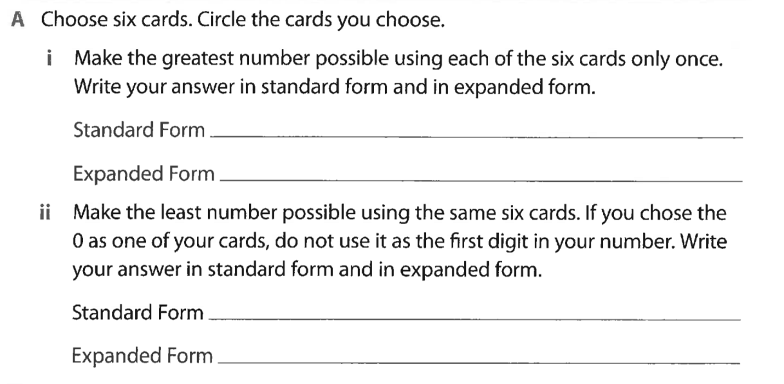

iii. What strategy did you use to determine the least number possible you could make? How do you know this strategy works?

____________________________________________________________________________________

____________________________________________________________________________________

B. Look at the standard form of your answers to Part A. Circle a digit that you used in both the greatest and least numbers. Did the value of the digit change between the two numbers? Explain why the value did or didn’t change between the two numbers.

____________________________________________________________________________________

____________________________________________________________________________________

C. Meghan picked cards 1, 5, 0, and 4 from the deck to build a four-digit number. When she rounded her number to the nearest 100, she got 4,500. What is the smallest number she could have built? What is the largest number she could have built?

Smallest_____________________________________________________________________________

Largest______________________________________________________________________________

